**Applications and their metrics:**

**Scenario:**

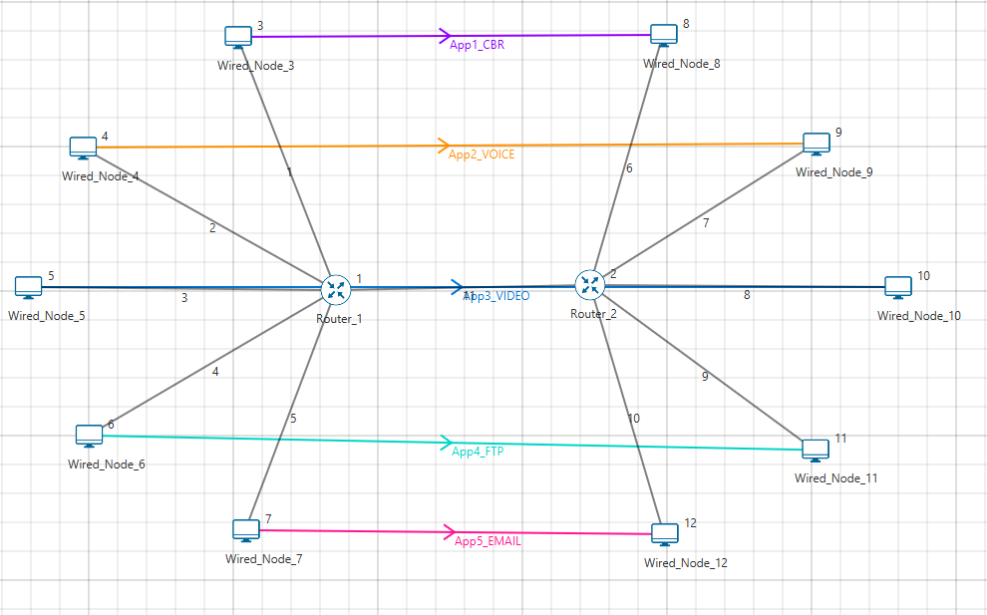

**Device Properties:**

The Device Properties are set according to the table given below:

|  |  |
| --- | --- |
| Wired Node & Router Properties | |
| TCP | Disabled |

**Link Properties:**

The Link Properties are set according to the table given below:

|  |  |  |  |  |  |  |  |  |  |  |  |
| --- | --- | --- | --- | --- | --- | --- | --- | --- | --- | --- | --- |
| Link Properties | Link 1 | Link 2 | Link 3 | Link 4 | Link 5 | Link 6 | Link 7 | Link 8 | Link 9 | Link 10 | Link 11 |
| Uplink Speed (Mbps) | 100 | 100 | 100 | 17 | 100 | 100 | 100 | 100 | 17 | 100 | 17 |
| Downlink Speed (Mbps) | 100 | 100 | 100 | 17 | 100 | 100 | 100 | 100 | 17 | 100 | 17 |
| Uplink BER | 0 | 0 | 0 | 0 | 0 | 0 | 0 | 0 | 0 | 0 | 0 |
| Downlink BER | 0 | 0 | 0 | 0 | 0 | 0 | 0 | 0 | 0 | 0 | 0 |

**Application Properties:**

The Application Properties are set according to the table given below:

|  |  |  |  |  |  |
| --- | --- | --- | --- | --- | --- |
| Application Properties | | | |  |  |
|  | **Application 1** | **Application 2** | **Application 3** | **Application 4** | **Application 5** |
| Application Type | CBR | VOICE | VIDEO | FTP | EMAIL |
| Source_Id | 3 | 4 | 5 | 6 | 7 |
| Destination_Id | 8 | 9 | 10 | 11 | 12 |
| Start_Time | 0 | 20 | 40 | 60 | 80 |
| End_Time | 20 | 40 | 60 | 80 | 100 |
| Generation Rate | 10Mbps | 10Mbps | 1.5Mbps | 16Mbps | 0.8Mbps |
| Packet_Size | 1460Bytes | 1460Bytes | Frame_Per_Sec =10 | 2000000  Bytes | 100000  Bytes |
| Inter_Arrival_time | 1168μs | 1168μs | Pixel_Per_Frame = 150000 | 1s | 1s |
|  | - | - | Mu =1 | - | - |

**Output:**

|  |  |  |  |  |  |
| --- | --- | --- | --- | --- | --- |
| Application | Traffic Generation Rate (Mbps)* | Throughput (Mbps) | Throughput (Calculated through formula) | Delay(micro sec) | Delay  (Calculated through formula) |
| CBR | 10 | 10.0 | 10.00 | 957.47 | 957.47 |
| Voice | 5 | 4.99 | 5 | 957.49 | 957.49 |
| Video | 1.5 | 1.53 | 1.53 | 466.50 | 466.50 |
| FTP | 16 | 16 | 16.8 | 490410.68 | 490410.68 |
| Email | 0.8 | 0.79 | 0.8‬ | 24611.32 | 24611.32 |